# **Name: Abdurrahman Qureshi**

# **Roll No: 210451**

Practical No: 3

**1) Addition of Two 8 Bit numbers CODE:**

.model small

.stack 100h

.data

x db 88h

y db 22h

res db 00h

.code

mov ax, @data

mov ds, ax

mov al, x

add al, y

mov res, al

mov ah, 4Ch

int 21h

end

**OUTPUT:**

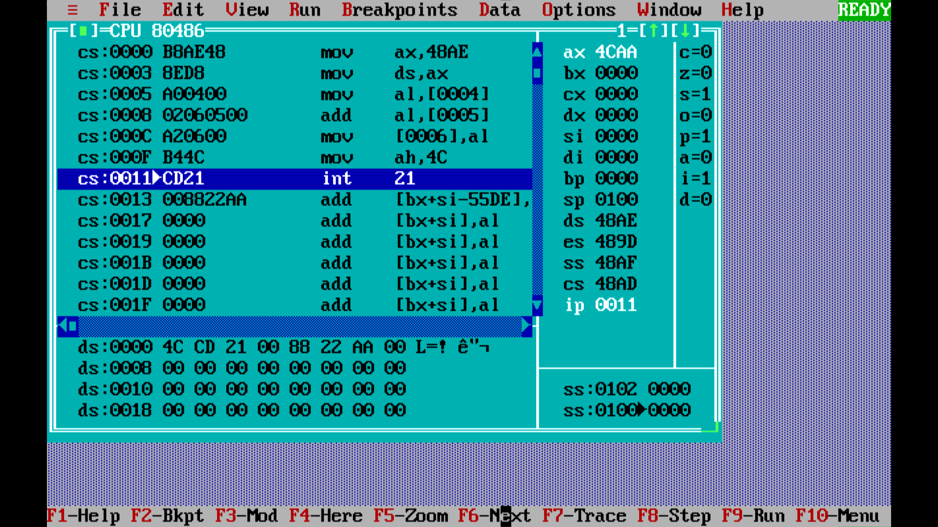

**2) Addition of Two 16 Bit numbers - CODE:**

.model small

.stack 100h

.data

x dw 0ABCDh

y dw 0F0F0h

res dw 0000h

.code

mov ax, @data

mov ds, ax

mov ax, x

add ax, y

mov res, ax

mov ax, 4C00h

int 21h

end

**OUTPUT:**

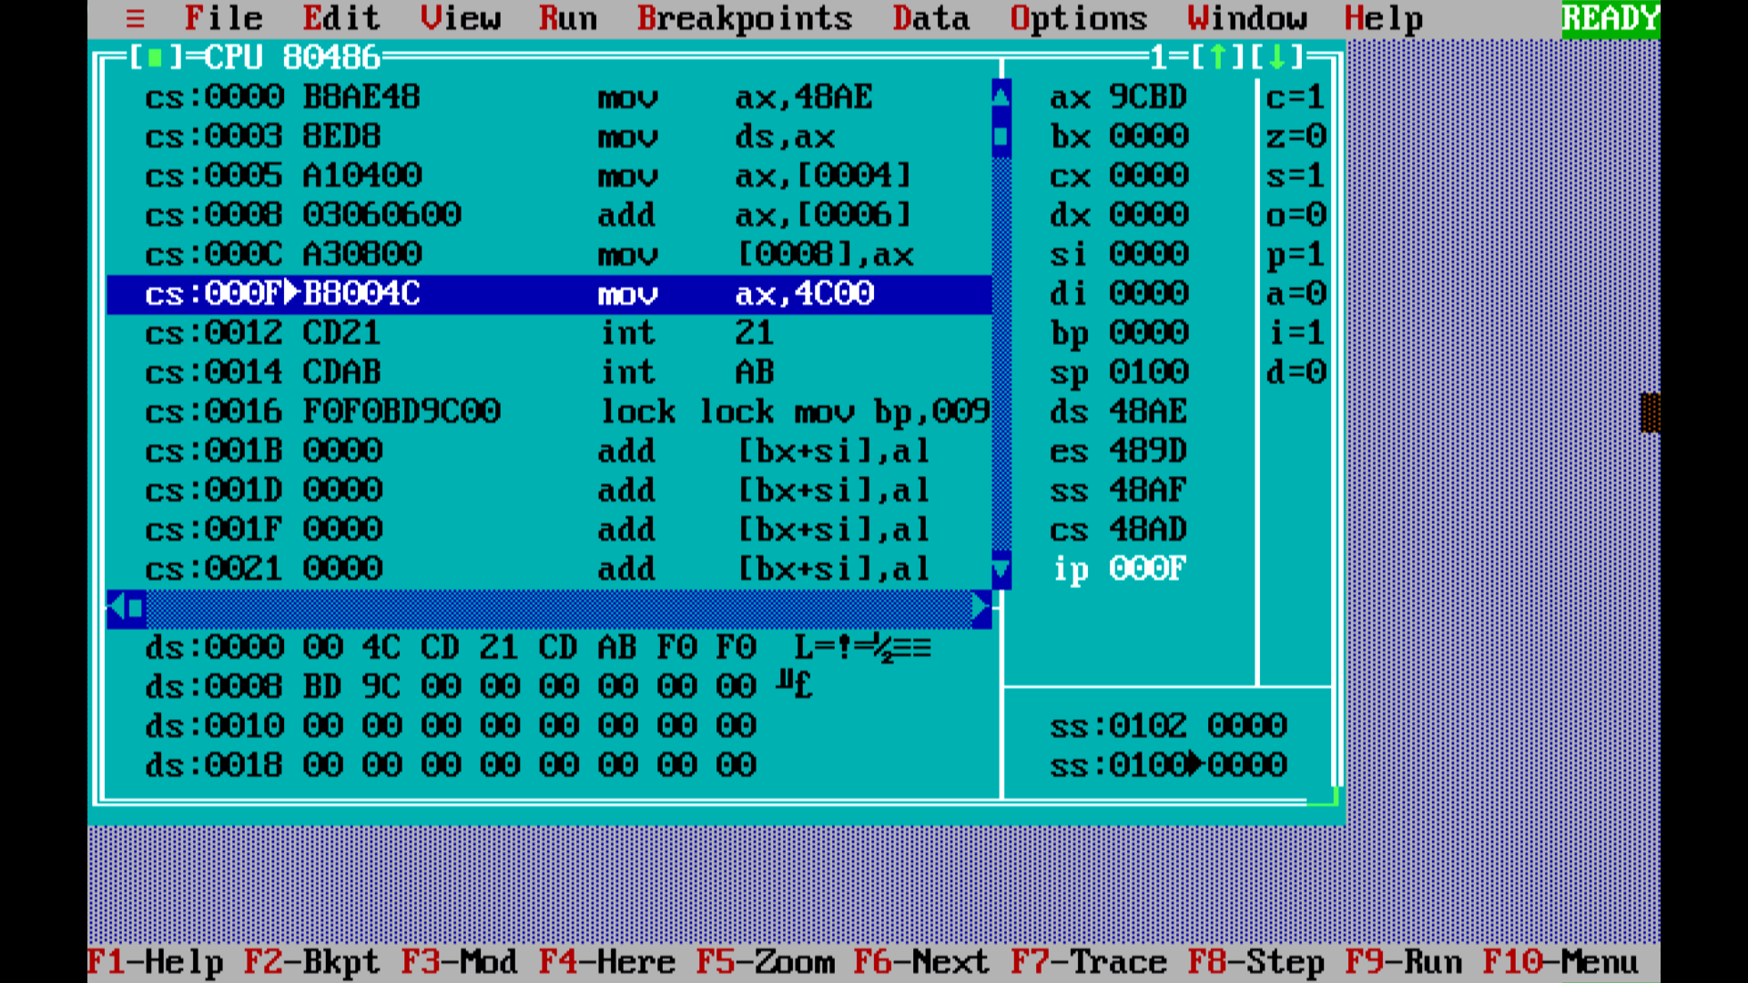

**3) Subtraction of Two 8 Bit numbers - CODE:**

.model small

.stack 100h

.data

x db 8Fh

y db 69h

res db 00h

.code

mov ax, @data

mov ds, ax

mov al, x

sub al, y

mov res, al

mov al, 4Ch

int 21h

end

**OUTPUT:**

